**Eligibility criteria**Nurses and/or midwives from low resourced settings in South East Asia and the South Pacific*, who care for sick and small newborns are eligible to apply for the Renee Collisson Neonatal Nurse Travel Grant to attend

the 12th Council of International Neonatal Nurses Conference in Australia 2026.

|  |  |
| --- | --- |
| Conference name | 12th Council of International Neonatal Nurses Conference. COINN 2026 |
| Conference dates | 25-28 August 2026 |
| Location | Darwin, Australia |
| Conference information link | <https://www.acnn.org.au/events/coinn-2026-darwin/> |

*Eligible Countries include: Cambodia, Fiji, Indonesia, Kiribati, Marshall Islands, Micronesia, Nauru, Palau, Papua New Guinea, Philippines, Samoa, Solomon Islands, Timor-Leste, Tonga, Tuvalu, Vanuatu, Vietnam

**Grant conditions**

* Applications **open Monday 1 September and close at 5 pm AEST on Friday 17 October** **2025**.
* Applicants will be notified by Friday 31 October 2025.
* Funding for an individual applicant is approximately $3000 AUD and can be used towards:
  + Return Economy flights from your closest capital city to Darwin, Australia
  + Accommodation at one of the nominated conference accommodation venues maximum 5 nights from Monday 24 August 2026
  + Conference registration, pre-conference workshops, conference dinner
  + Travel insurance (compulsory)

**Checklist**Complete checklist on page 2. Explore all web links and confirm that you will be able to meet Australian visa requirements. Please do this **PRIOR** to submitting your application.

**Budget**

Complete the budget table on page 3. Items should be detailed and may be supported by receipts or screen shots of actual or approximate costings. Example, ‘Airfares’ - include airline and flight details.

**Application Form**

Compete the Application Form on pages 4 and 5.

**Application submission**

Email completed checklist, budget, application form and any supporting documents to [lrcsig@acnn.org.au](mailto:lrcsig@acnn.org.au) by 5pm AEST Friday 17 October 2025.

**Checklist for submitting an application**

Completing the checklist - ensure all statements have either Yes or No marked. Statements not completed will stop the application from proceeding to assessment.

|  |  |  |  |
| --- | --- | --- | --- |
| **Section 1: Eligibility Criteria MUST be YES to apply** | **Yes** | | |
| I am native to and work with neonates in one of the following low resourced countries:  Cambodia, Fiji, Indonesia, Kiribati, Marshall Islands, Micronesia, Nauru, Palau, Papua New Guinea, Philippines, Samoa, Solomon Islands, Timor-Leste, Tonga, Tuvalu, Vanuatu, Vietnam |  | | |
| I am a nurse/midwife currently working in a setting that cares for neonates or supports neonatal education or neonatal research |  | | |
| I have approval from my manager/nursing director/head of hospital to attend if I am successful in obtaining a travel grant |  | | |
| **Section 2: Passport and Visa Requirements MUST be YES to apply** | **Yes** | | |
| I have a current passport that does **not** expire until **after** 1 March 2027 |  | | |
| I have explored the Australian Government visa website and understand the requirements in applying for a visa <https://immi.homeaffairs.gov.au/visas/getting-a-visa/visa-finder/visit> |  | | |
| I have explored the Australian Government webpage ‘Meeting our health requirements’ and understand that I may be required to complete health examinations as part of the visa application process.  <https://immi.homeaffairs.gov.au/help-support/meeting-our-requirements/health> |  | | |
| I have explored the Australian Government webpage ‘Meeting character requirements for visas’ and will be able to meet these requirements and I understand I may be asked to provide a police certificate.  <https://immi.homeaffairs.gov.au/help-support/meeting-our-requirements/character> |  | | |
| **Section 3: Budget and Finances MUST be YES to apply** | **Yes** | | |
| I have completed the Budget table on page 3 of this application |  | | |
| I have enough money, or access to enough money, to support myself while in Australia. Personal finances to cover expenses that are not covered by this application for example - meals, taxi’s, incidentals. |  | | |
| **Section 4: Additional information** | **Yes** | | **No** |
| I am hoping to attend the conference as a presenter (intending to submit an abstract for a poster or oral presentation) *If yes please provide brief details of the topic of your abstract in the application form.* |  |  | |
| I have attended Taking Paediatrics Abroad and/or ACNN Zoom sessions |  |  | |
| **Section 5: Agreement to terms and conditions** | **Yes** | | **No** |
| I consent to my name and the travel grant being announced via ACNN social media |  |  | |
| I have completed all sections of the checklist |  |  | |
| I have read and agree to the above terms and conditions.  Signature (electronic or typed) and Date | | | |

**Budget**

**Estimated budget and costs to attend the COINN Conference in Australian Dollars (AUD)**

Budget items should be detailed and may be supported by receipts or screen shots of actual items or approximate costings. For example, ‘Airfares’ – include airline and flight details.

COINN Conference information available: <https://www.acnn.org.au/events/coinn-2026-darwin/registration/>

|  |  |  |  |  |
| --- | --- | --- | --- | --- |
| **Budget Item** | **Total Cost**  **(AUD)** | **Funding request**  **ACNN** | **Funding received other source** | **Contribution**  **by self** |
| Australian Visa | $200 |  |  |  |
| Return airfares **(provide details):** |  |  |  |  |
| Travel insurance - compulsory **(provide details):** |  |  |  |  |
| Conference Registration (3-day registration including welcome reception) | $350 | $350 | $0 | $0 |
| Pre-conference workshop/s |  |  |  |  |
| Conference farewell dinner - Friday night |  |  |  |  |
| Accommodation - 5 nights maximum funded by this travel grant (from Monday 24 August to Saturday 29 August). **Provide name of accommodation venue:** |  |  |  |  |
| Health examination/certificate |  |  |  |  |
| Estimate other personal costs. Items to consider: local transport, meals, internet, phone SIM card etc. This may be required as part of Visa application. |  | *Not applicable* |  |  |
| **Total** |  |  |  |  |

**Application Form**

Complete all following sections of the application in as much detail as possible and email the completed application form to [lrcsig@acnn.org.au](mailto:lrcsig@acnn.org.au) by 5 pm AEST on Friday 17October 2025.

**YOUR DETAILS**

|  |  |
| --- | --- |
| Full Name as displayed in your passport |  |
| Passport country of issue and date of expiry |  |
| Home address |  |
| Email address |  |
| Phone number |  |
| Preferred means of contact (e.g. What’s App, Face Book Messenger) include contact details |  |

**YOUR WORK DETAILS**

|  |  |
| --- | --- |
| Where you work eg name of Hospital, University, Community Centre |  |
| Your current workplace  eg neonatal / special care nursery, paediatric, maternity ward - postnatal / labour |  |
| Role/Position  eg Nurse, Midwife, Lecturer |  |
| How long have you been caring for newborns or providing newborn education? |  |

**WHY SHOULD YOU BE CONSIDERED FOR THIS TRAVEL GRANT?**

|  |  |
| --- | --- |
| Briefly describe why you would like to attend this conference. |  |
| Briefly describe any activities you have taken to improve outcomes for newborns and their families. |  |
| Have you had previous contact with the ACNN Low Resource Countries Special Interest Group or COINN? E.g. Email communication, online training, in-county education? Please give details. |  |
| Anything else you would like to tell us to support your application? |  |

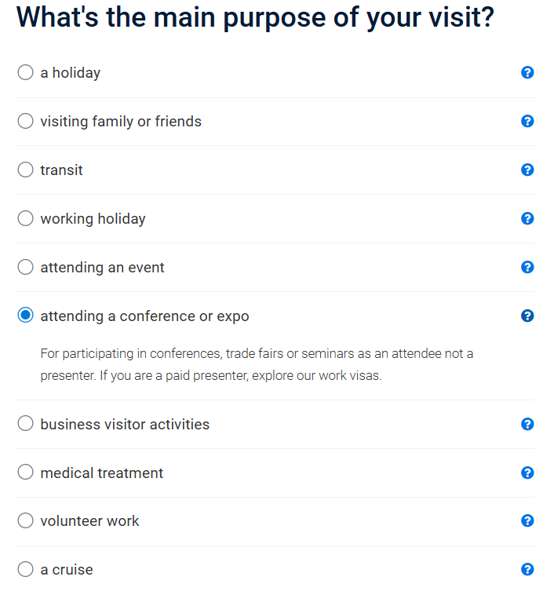

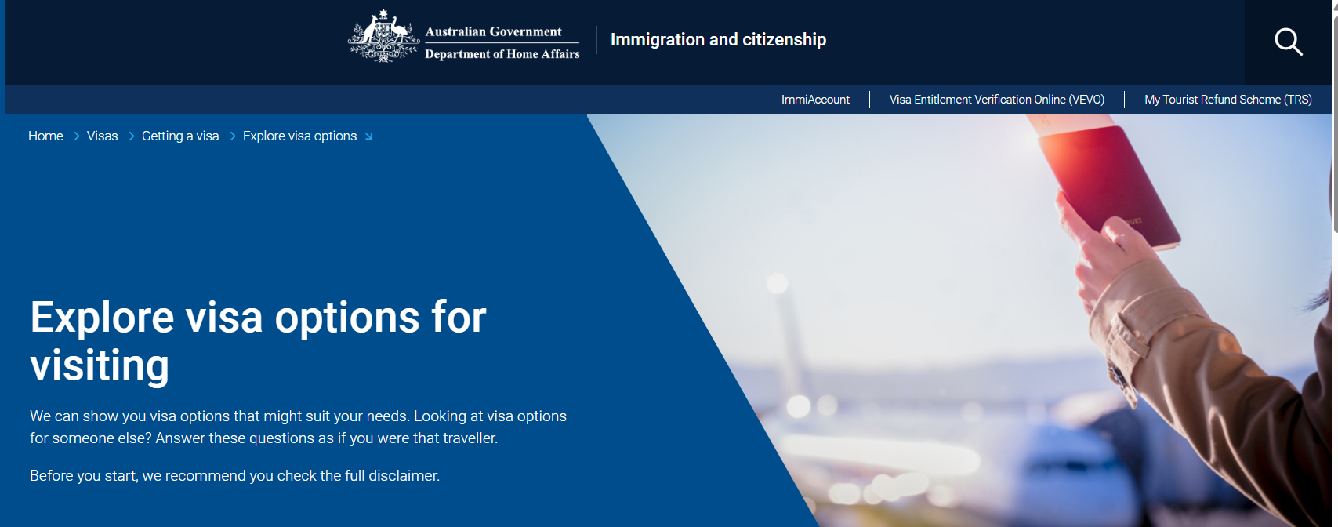

[**https://immi.homeaffairs.gov.au/visas/getting-a-visa/visa-finder/visit#**](https://immi.homeaffairs.gov.au/visas/getting-a-visa/visa-finder/visit)